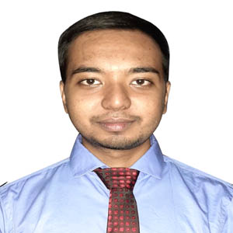

**BIPLOB KUMAR PAINE**

**Organized, Technical, Analytical**

Being an engineering graduate, I am willing to work in such an environment which provides me challenges and opportunities to expose my knowledge and potentials through my technical skills and hard work. I have a proactive attitude and like to find positive ways to stimulate and engage with people. I believe that if I am given the opportunity to serve, I can provide dedication and devotion to the assigned job.

**2013**

* **BSc in Computer Science and Engineering**

American International University-Bangladesh (AIUB), Dhaka.

G.P.A- 3.59 out of 4.00

N.S Govt. College, Natore.

G.P.A- 4.33 out of 5.00

* **Higher Secondary Certificate**

**2015**

United International University (UIU), Dhaka.

Major: Cyber Security

* **MSc in Computer Science and Engineering**

**EXPERIENCE**

annanto2248@gmail.com

**🖂**

**🕽**

+8801772976852

**🏠**

Nadda, Kalachadpur, Dhaka

**EDUCATION**

**2022-Present**

**CONTACT**

**2016-2021**

* Completed 06 months internship as “Trainee Cloud Network Engineer” at MF ASIA LTD. In my internship period, I have some responsibilities. These are

**-** Working on a project of IT infrast-

ructure monitoring system using

Nagios.

- Working on Centos 7 and Ubuntu

22.4 LTS.

- Network Monitoring (Using

Nagios)

- Smoke Testing (Tested the whole

site after upgradation).

- Client Support.

* **Secondary School Certificate**

Natore Govt. Boys’ High School, Natore.

G.P.A- 5.00 out of 5.00

**G.P.A- 5.00 out of 5.00**

**SKILL and Achievement**

* Completed CCNA 200-301 at AIUB ICE and got certificate from CISCO.
* Completed MTCNA at AIUB ICE and got certificate from AIUB ICE.
* Completed Linux Administration Bootcamp: Go from Beginner to Advance from Udemy.
* Completed Red Hat System Administration I 7, II 7, III 7 at UIU Cisco Academy and got certificate from Red Hat Academy.

**LANLUAGE**

**REFERENCE**

* Bangla (Native).
* English

**DECLARATION**

**REFERENCE**

* Manik Roy

Director

MF ASIA LTD

E-mail: [manik.roy@metafour.com](mailto:manik.roy@metafour.com)

* DR. MOHAMMAD NURUL HUDA

Director & Professor

Dept. of MSCSE, UIU

E-mail: [mnh@cse.uiu.ac.bd](mailto:mnh@cse.uiu.ac.bd)

Undersigned certified that to the best of my knowledge and belief this resume correctly describes my qualifications and me. Any willful misstatement describes here in may lead to my disqualification or dismissal, if I employed.



(Signature)

--------------------